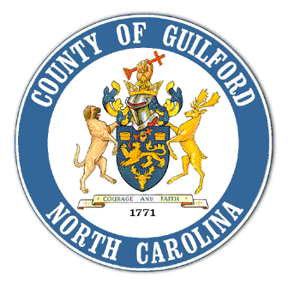

If you’re interested in youth gang activity in our community, we invite you to join us for a presentation of the:

***Guilford County***

***Gang Assessment***

*This assessment combines demographic, school, and law enforcement data along with youth, adult, and gang member perceptions to better understand the current gang dynamic in the County and what can be done to reduce gang activity.*

**December 10, 2010**

**12:30 to 1:30 pm**

**Location: Commissioner’s Meeting Room**

**Old Courthouse, 301 W. Market Street, Greensboro, NC**

**For additional meeting details contact Chuck Hodierne at Youth Focus at 274-5909, CHodierne@Youthfocus.org**



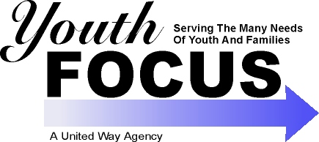



**Facts about Gangs in Guilford County:**

* Several risk factors for youth gang involvement exist in our community.
* Gangs are currently active in our neighborhoods and schools.
* Our community is working to better understand the gang problem and make efforts to combat it.